Industrial AI Foundation
Twin Builder Models
TUTORIAL
Release Version: 2.5
Metadata Table
Field | Value
Asset / Solution Name | Industrial AI Foundation / Twin Builder and Viewer
Domain / Area | Digital Twin / Visual monitoring and alerts
Owner (Team/Person) | Tournier, Florian
Reviewers | Susarla, Aditya, Rane, Chetankumar
Status | Published / Complete
Confidentiality | Internal / Confidential
Source of Truth | Summary - Overview
Related Assets / Alternatives | Twin Builder UI Guide

Contents
Introduction 3
Purpose 3
Contact 3
Target Audience 3
Prerequisites 3
Related Links 3
Glossary 3
Working with Models 4
Upload Model 4
View Model 4
Delete Model 5
Upload New Version 5

Introduction
Industrial AI Foundation (IAI) is a collection of software accelerators and tools that can be assembled to deliver client solutions. IAI accelerates the integration of product, process, and live data from disparate IT and OT systems, creating a comprehensive and contextualized view of operations to enable better decisions and optimized processes.
IAI’s Twin Builder application is implemented as Micro-Frontends (MFE) based on React. Twin Builder allows an admin user to create a dynamic floor layout using a Drag and Drop mechanism through a web-based user interface. The 3D visuals created in Twin Builder are viewable in Twin Viewer.
IAI has two versions- decoupled and coupled. In the decoupled version, only IAI models are used, and they are stored in the IAI space. In the coupled version, both 3DCE models and IAI models are used, and the models are stored on the 3DCE tenant. Additionally, the coupled version has a 3D model conversion feature which allows converting fbx, obj, and CAD files to glb.

Purpose
This tutorial teaches the reader how to upload, edit, and view models directly in the Twin Builder UI.

Contact
- chetankumar.rane@accenture.com
- rishabh.b.joshi@accenture.com

Target Audience
- IAI End Users
- Plant Designers
- Client IT Admins

Prerequisites
- Twin Builder application must be deployed.
- The client should have 3D models (files) available to upload.
- The 3D model component hierarchy should have one root node (parent).
- The 3D models should have good rotational angle and scaling aspects.
- A compatible browser (Google Chrome or Microsoft Edge) must be installed.

Related Links
- IAI on CDF
- IAI on Azure
- Release Notes
- IAI Documents

Glossary
Term | Definition
3D Model | A digital representation of a physical object in three dimensions, used for visualization and analysis.
GLTF/GLB | File formats commonly used for 3D models; GLTF is JSON-based, and GLB is its binary version.
Root Node (Parent) | The top-most node in a 3D model’s hierarchy, serving as the parent to all other nodes.
Rotational Angle | The orientation or spin applied to a 3D model along its axes.
Scaling | The process of resizing a 3D model to fit specific dimensions or proportions.
Tag Field | The area in the application where the selected plant or object is displayed.

Working with Models
The following pages explain how to upload, search, and view models.

Upload Model
- Select a plant from the drop-down menu in the upper-right corner of the application.
- Put a title for the model to be uploaded.
- Confirm that the selected plant is shown in the Tag field.
- Upload a model in the valid file format (GLTF, GLB) and upload a thumbnail image.
- Click the UPLOAD MODEL option at the bottom of the dialog window to upload a model.
If the same model is required for a different use, then upload a copy of the model and save it with a different name. Avoid duplicate names for ease of use and identification.
Note that the model’s name must not exceed 25 characters.
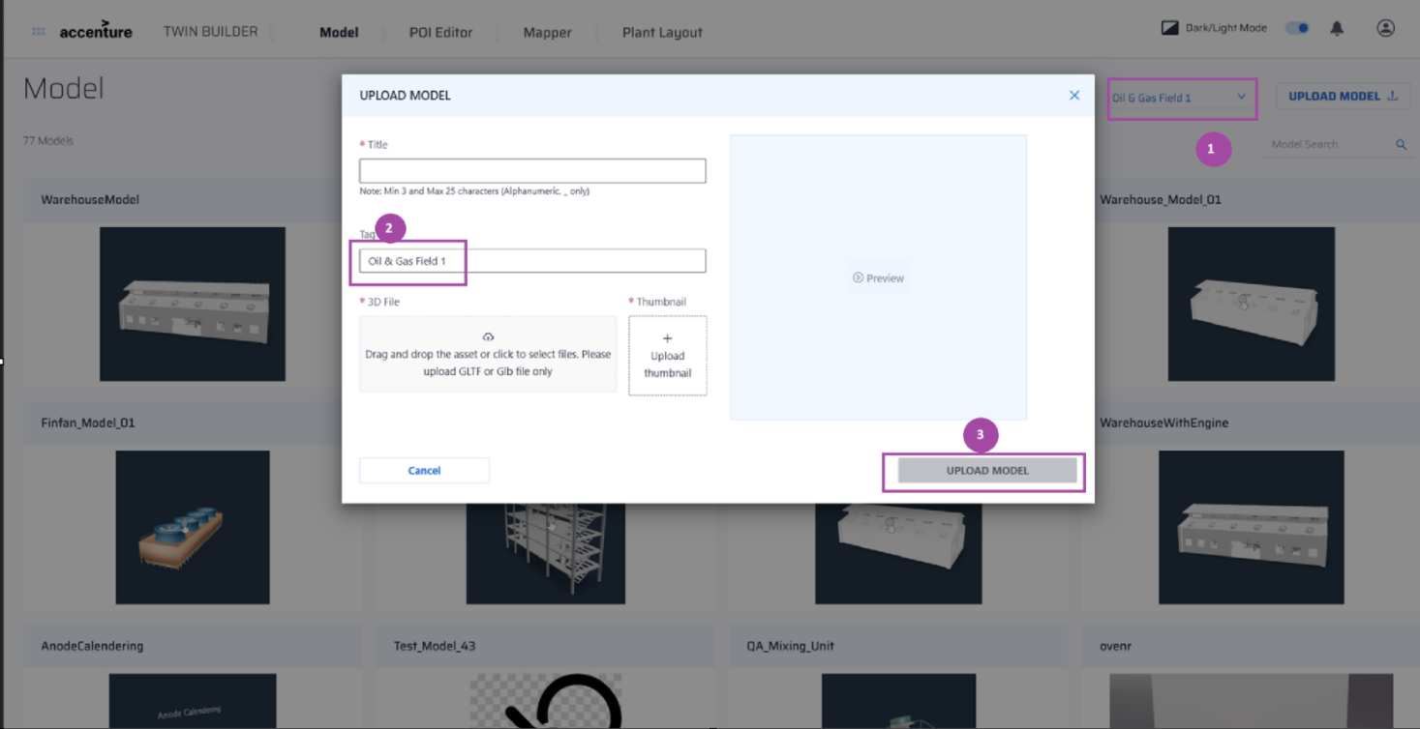

View Model
Click on the tile that represents the new model to see a 3D view of the model. This page includes controls that can be used to upload a new version or switch to a different version.
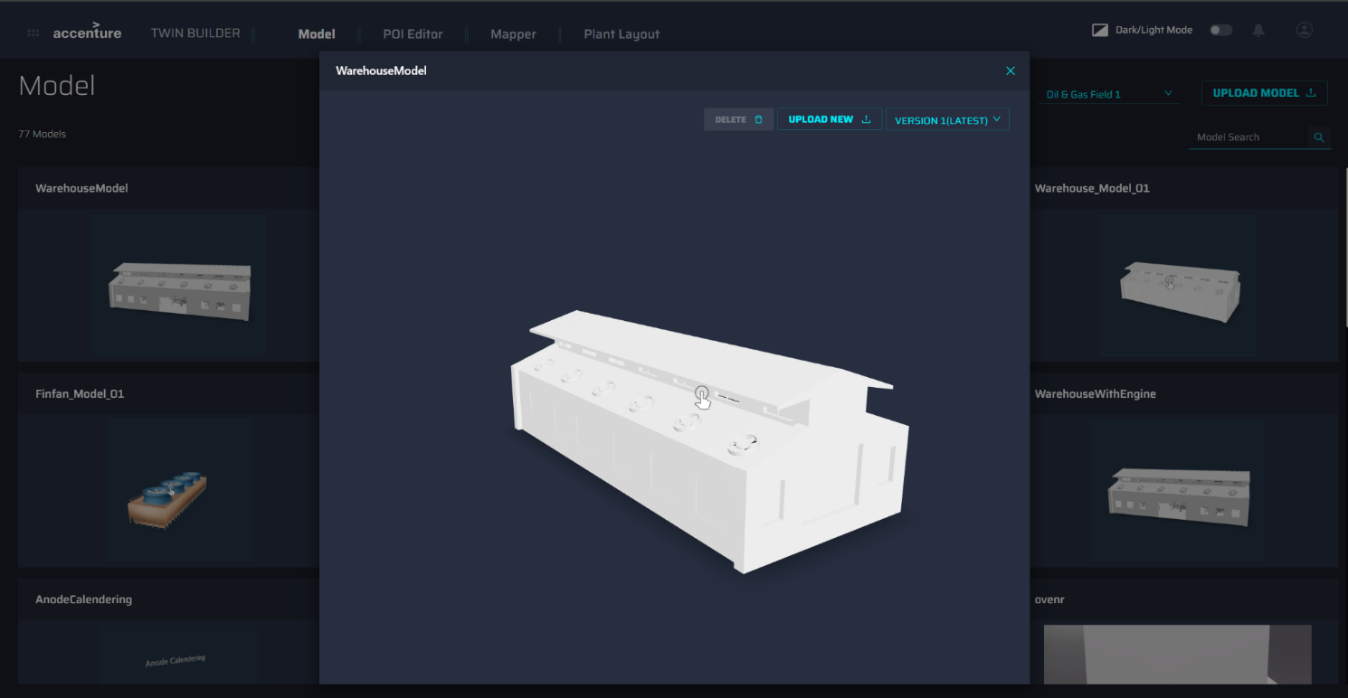

Delete Model
To delete a model, click on the Delete (1) button. To delete all versions of the model, click on the Delete All (2) button.
There are certain validations made before the model is deleted, which are as follows.
- If POIs are added to the Model, then the model cannot be deleted until all POIs are deleted.
- If the Model is mapped using either Model Mapper or POI Mapper application, then the model cannot be deleted until the mapping is deleted.
- If a Model is placed in any layout, then it cannot be deleted until the layout is deleted.

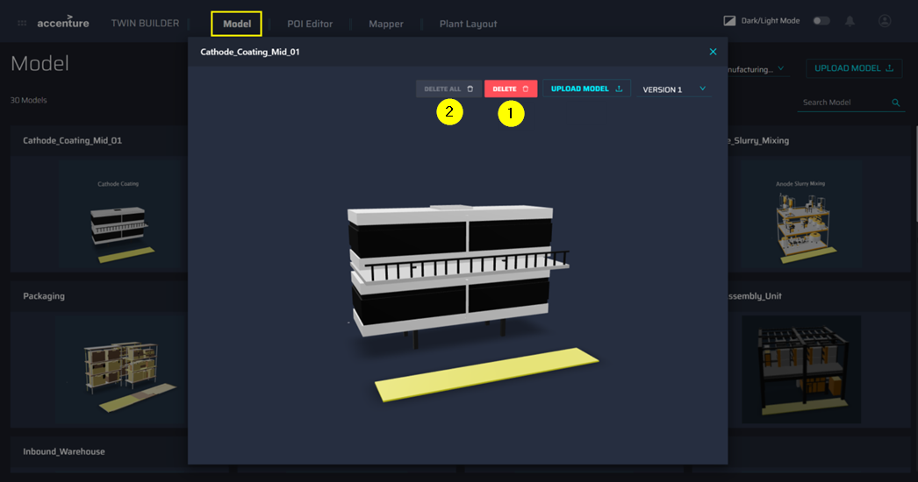

Upload New Version
- To upload a new version of this model, Click on UPLOAD NEW. A new dialog window opens to upload the new version.
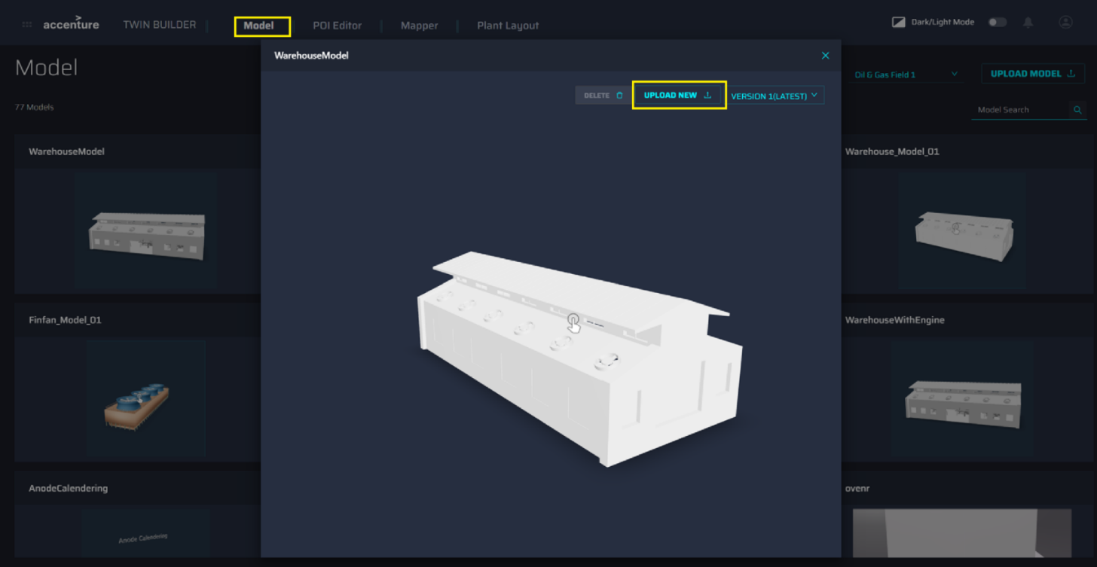
- Confirm that the selected plant is shown in the Tag field

- Update the fields and click on the Update New Version option.
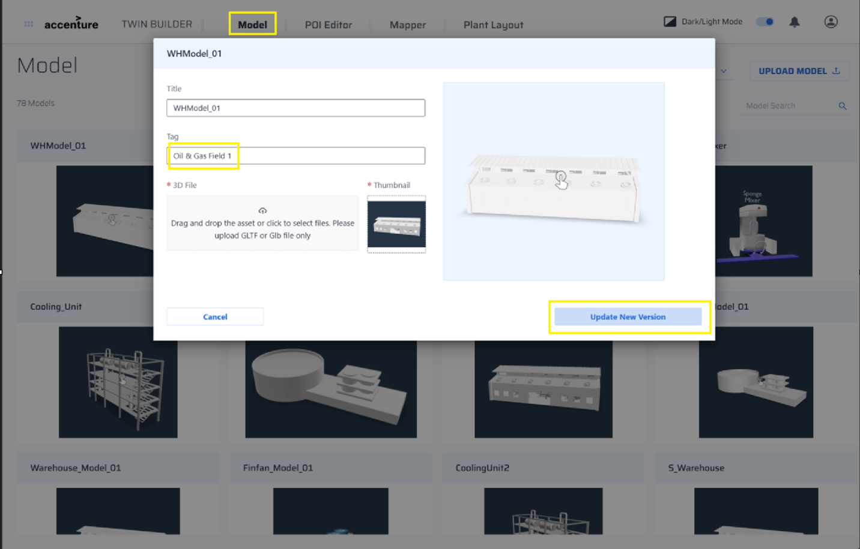

- When the model update is complete, the user can view the list of versions in the drop-down menu and select a version to view it in the window.
